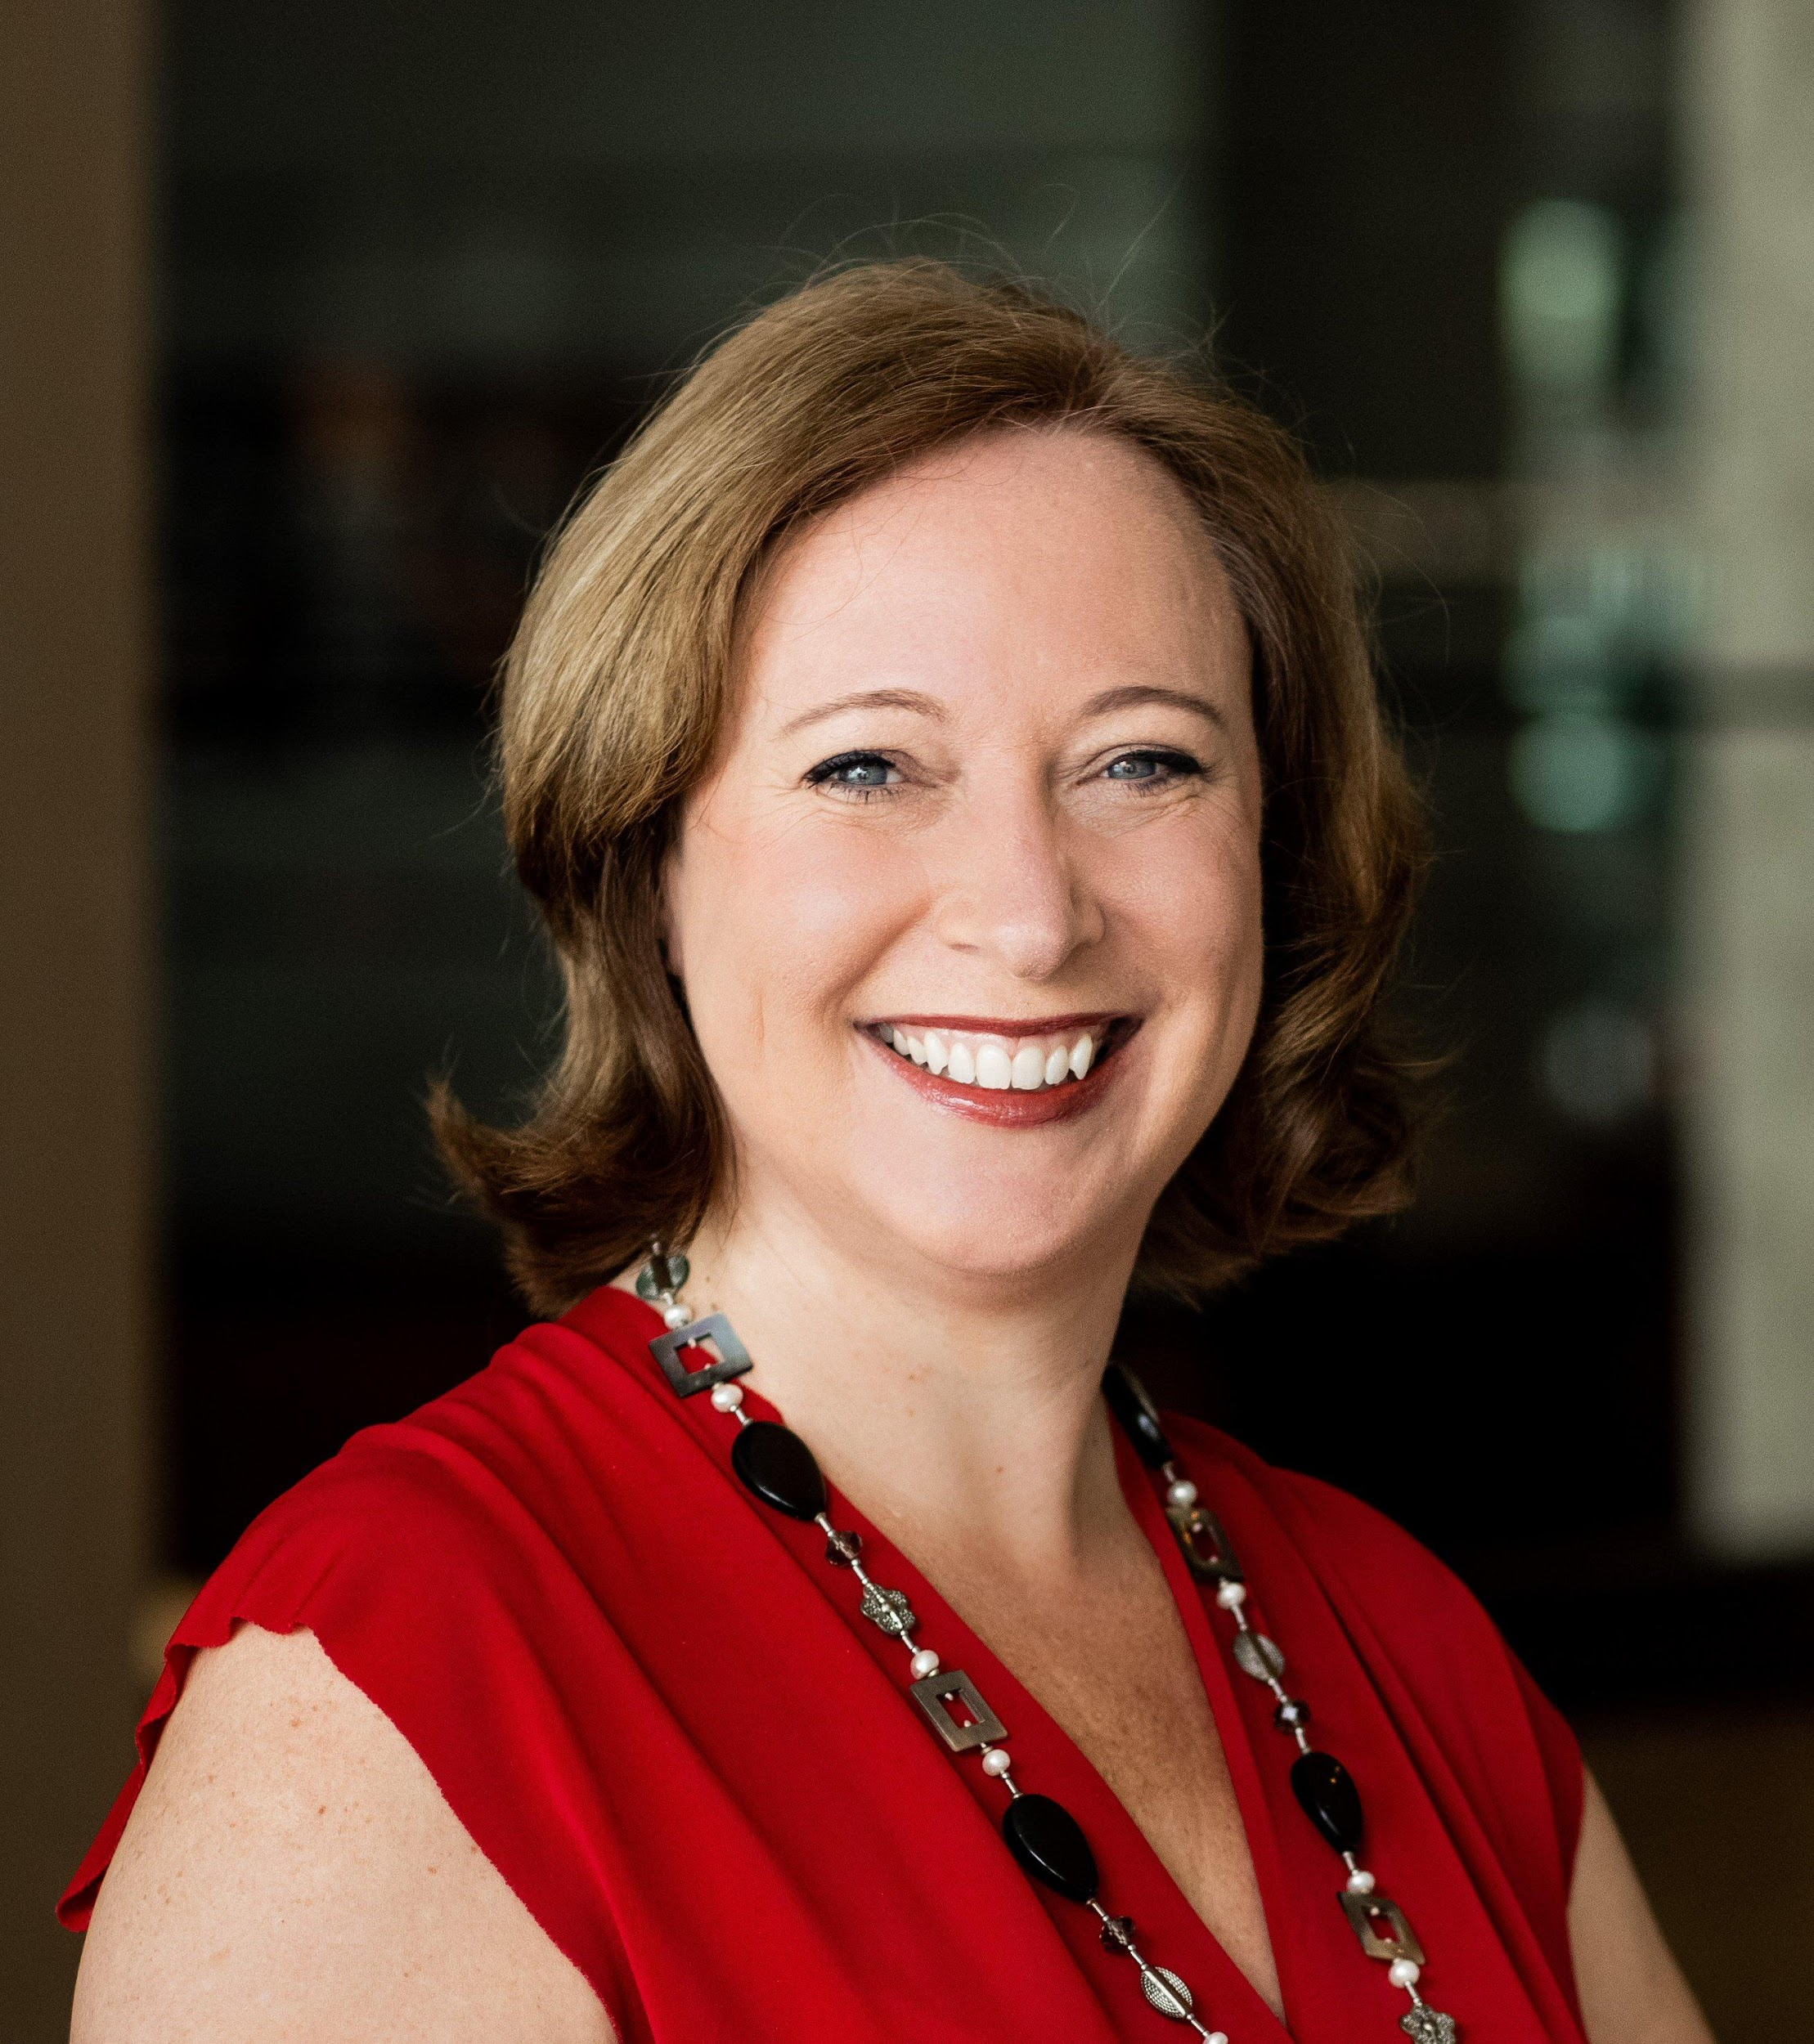

# Speaker PROFILE - Claire Boscq

**No.1 Woman CX Global Guru | Keynote Speaker | BizShui™ Creator**

**Elevate CX, Energise People & Places**

1. **BIO (150 words)**

Claire Boscq is the No.1 Woman on the Customer eXperience Global Gurus list, an international keynote speaker, and Founder of the Jersey Customer eXperience Alliance. With over three decades of expertise in Customer eXperience, mystery shopping, and employee engagement, she is an authority in the CX industry.

As the creator of the BizShui™ Method, Claire blends the ancient wisdom of Feng Shui with modern business needs to help organisations increase their profitability by elevating their Customer eXperience and energising their people and harmonising their places—so leaders and teams feel happy, valued, and proud of the difference they make.

Claire is the author of four books, including two best-sellers, and has delivered keynotes in over 30 countries, in both English and French. She is a passionate advocate for nurturing cultures built on Trust, Engagement, and Care and brings high energy and heart to every stage she steps on.

**Claire—elevating CX, one SMILE at a time.**

1. **Core topics**

* Employee Experience, engagement & Well-being
* Feng Shui, Environment Psychology
* Customer Experience & Loyalty
* Mystery Shopping, Customer Insight
* Trust, Engagement, Care Culture

1. **Services**

* Keynote Presentation Stage & Virtual
* MC (Master of Ceremony)
* Workshops, Break out room, Webinars

1. **Testimonials**

‘Claire is a true professional. Her enthusiasm shines through on the stage and her passion for what she does is unparalleled. Keeping a virtual audience entertained and engaged is no easy feat but Claire managed it with ease. She is also incredibly easy to work with and an excellent communicator. I would highly recommend Claire to speak at any event.’ Richard Kenny, COO at ARCET Global

1. **Signature Talk - BizShui™: Elevating CX by Energising People and Places**

What if real business transformation doesn’t start with systems or spreadsheets… but with ENERGY? Energy in your people, your places, and your purpose.

In this inspiring keynote, Claire Boscq introduces BizShui™ — a unique blend of ancient Feng Shui and modern business practices. By aligning people, environments, and culture, Claire reveals how to boost well-being, unlock performance, and deliver exceptional customer eXperiences. Because CX isn’t just something you design — it’s something you feel.

* Discover how energy in your people, places, and purpose shapes the customer experience.
* Learn practical tools from the BizShui™ method to create more harmonious, high-performing environments.
* Leave inspired to transform your workplace culture and deliver CX that’s truly felt, not just designed.

1. **Social Media Handles**

<https://www.linkedin.com/in/claireboscq/>

<https://www.youtube.com/c/ClaireBoscq>

<https://www.facebook.com/claireboscqkeynotespeaker>

<https://www.instagram.com/claireboscq/>

<https://www.tiktok.com/@claireboscq>

<https://twitter.com/ClaireBoscq>

**Website**

<https://www.claireboscq.com/>

**Showreel**

<https://youtu.be/wJ-idr1T_Tc>

1. **Contact me or book a Discovery Call**

[BOOK A BE INSPIRED TO THRIVE CALL](https://outlook.office.com/bookwithme/user/55608320ac65421780540b47cb2d297a@claireboscq.com/meetingtype/Cmy4Gd1ZmEiwyg4y3x5x4w2?anonymous) Call me: +44 7797 828950 Email: hello@claireboscq.com

**Elevating CX, one smile at a time.**