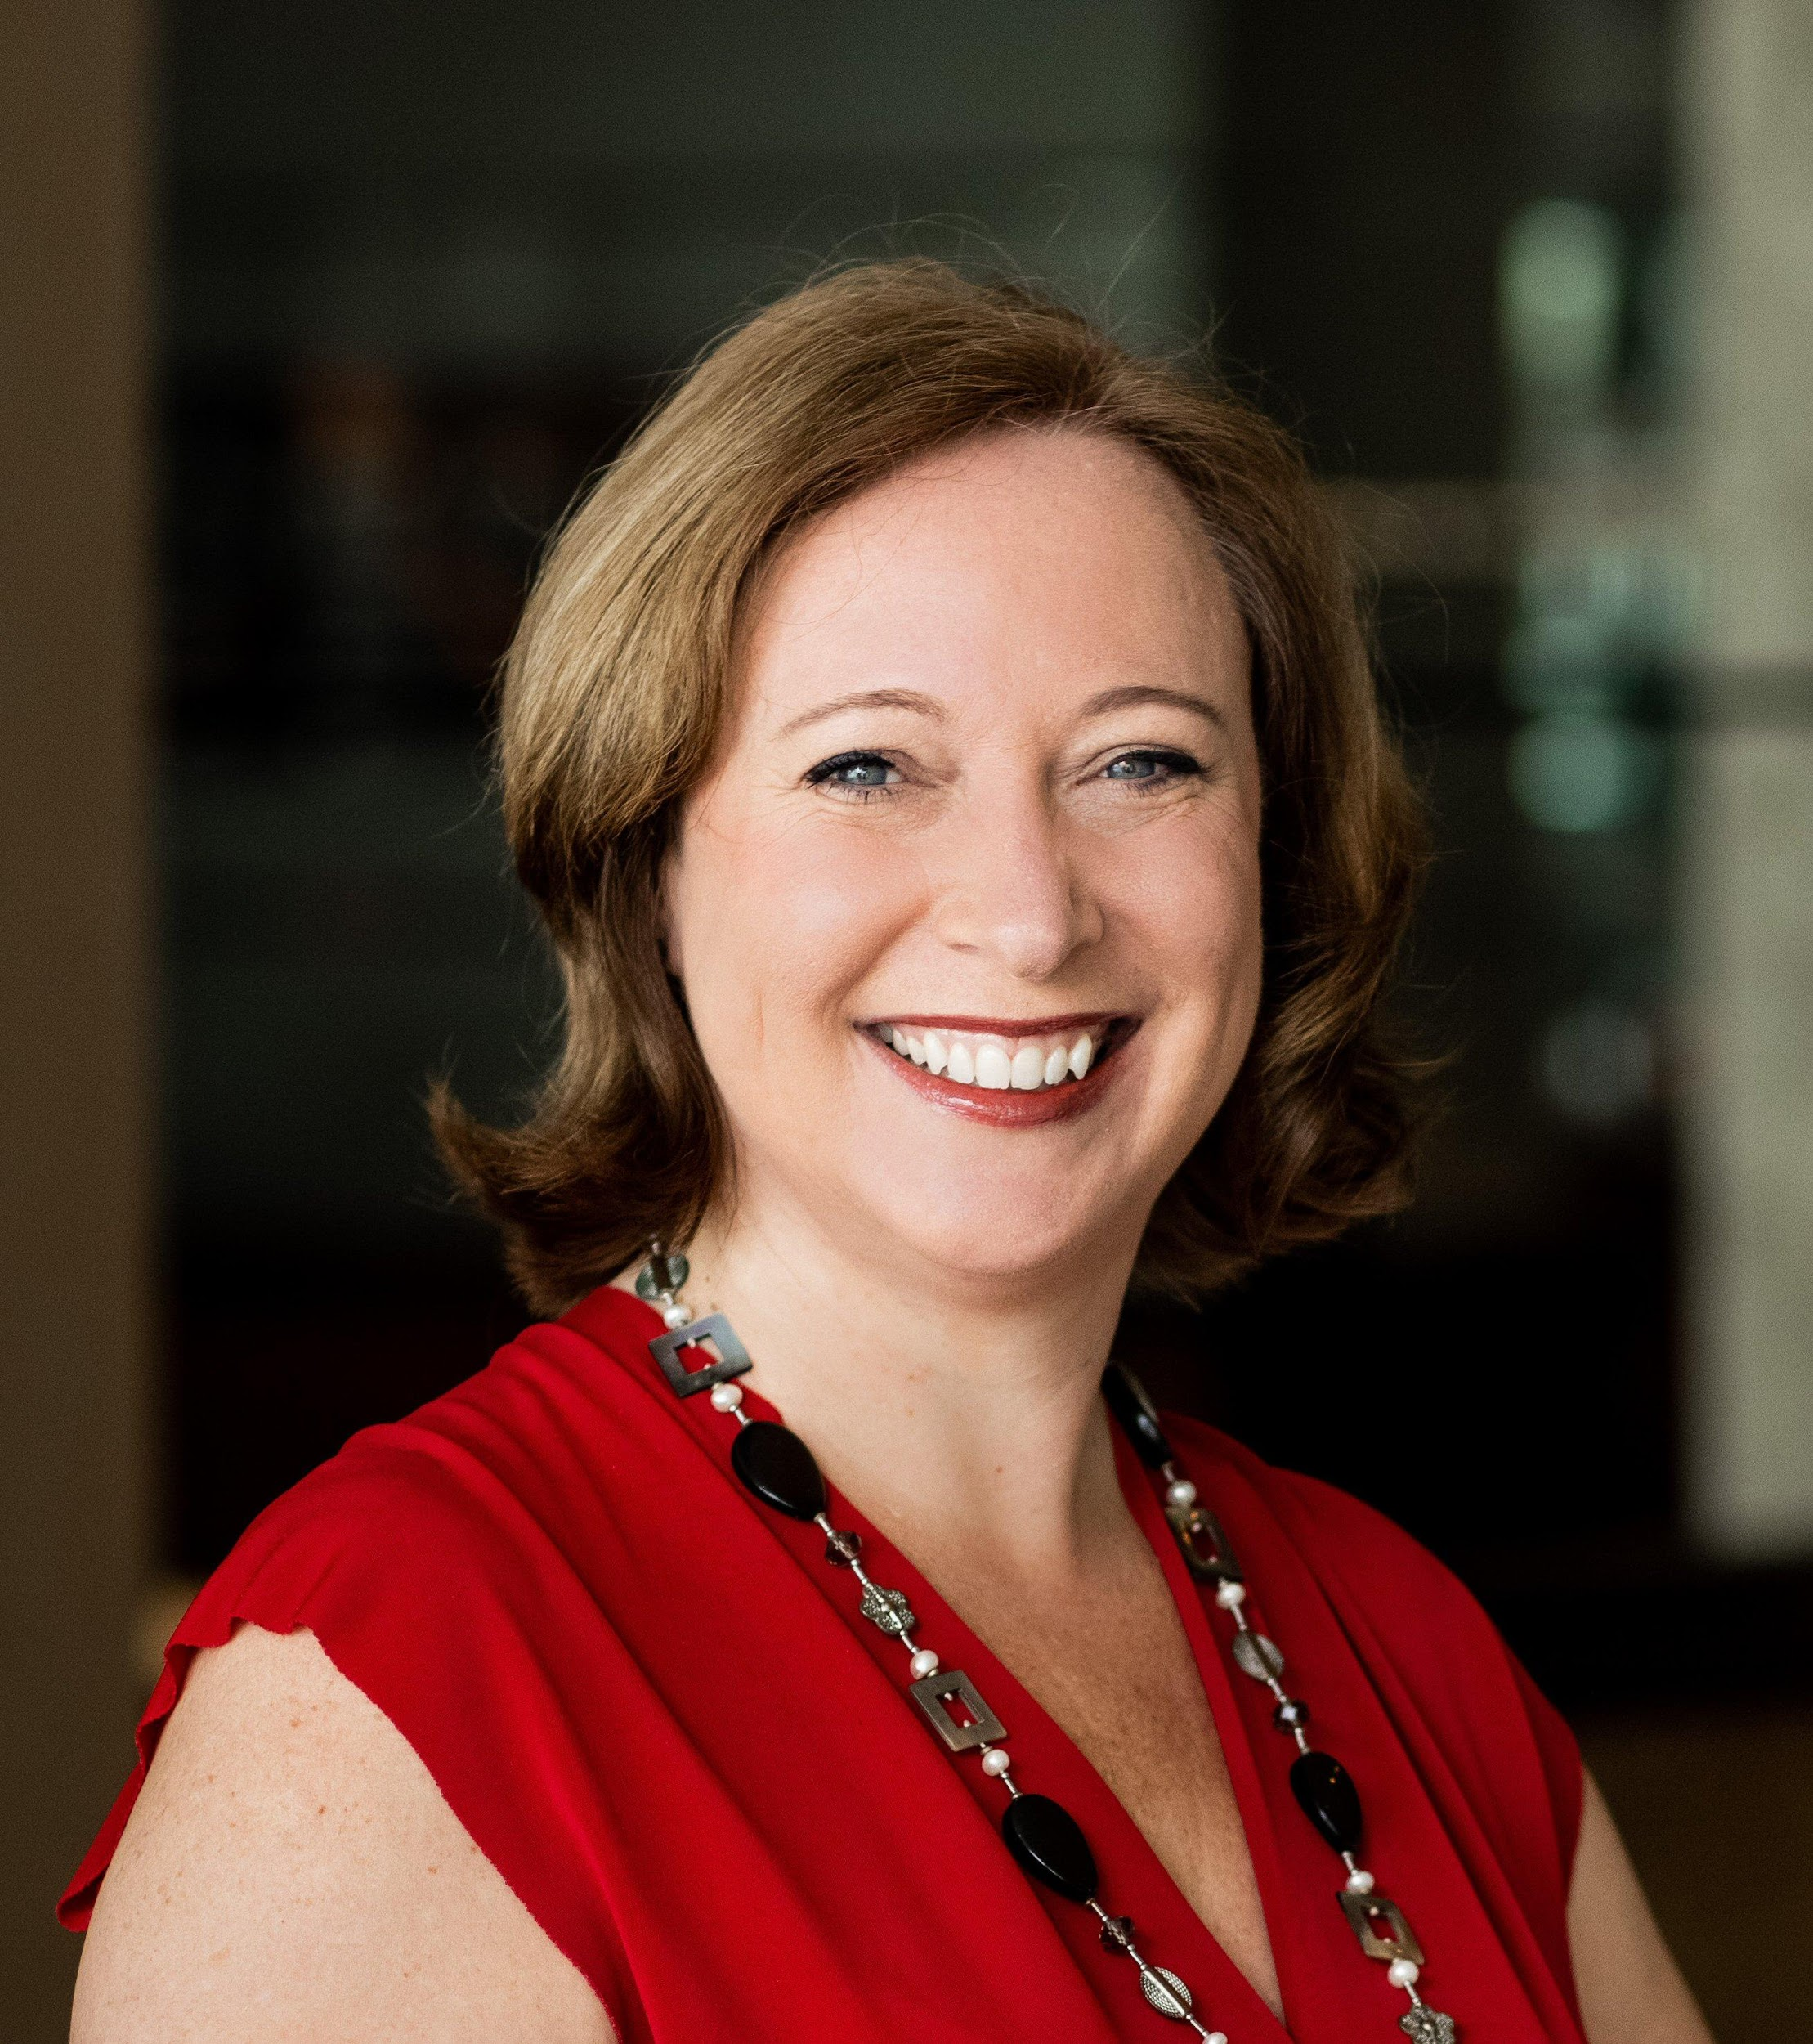

Speaker PROFILE - Claire Boscq CSP
No.1 Woman CX Global Guru | International Keynote Speaker |
Heart-Led Business Growth Blueprint™ Creator

- BIO (160 words)
Claire Boscq CSP is the No.1 Woman on the Customer eXperience Global Gurus list, an international keynote speaker, and creator of the Heart-Led Business Growth Blueprint™. With over 30 years of expertise in Customer eXperience, mystery shopping, and employee engagement, she is recognised worldwide as a leading authority in the CX industry.
Through her Heart-Led Business Growth Blueprint™, Claire helps organisations elevate customer and employee experience by energising their people, harmonising their spaces, and leading with heart. Soulful in essence and strategic in action, this approach blends ancient Feng Shui principles with modern business strategy.
Author of four books, including two best-sellers, Claire was awarded, in 2025, the prestigious CSP designation having delivered transformative keynotes in more than 30 countries, in both English and French. A passionate advocate for soulful yet strategic leadership, she brings infectious energy, authenticity, and a touch of French flair to every stage.
Elevating Customer eXperience, one heartbeat at a time.

- Core topics
- Customer Experience & Loyalty
- Employee Experience, engagement & Well-being
- Feng Shui, Environment Psychology
- Mystery Shopping, Customer Insight
- Trust, Engagement, Care Culture

- Services
- Keynote Presentation Stage & Virtual
- MC (Master of Ceremony)
- Workshops, Break out room, Webinars

- Testimonials
‘Claire is a true professional. Her enthusiasm shines through on the stage and her passion for what she does is unparalleled. Keeping a virtual audience entertained and engaged is no easy feat but Claire managed it with ease. She is also incredibly easy to work with and an excellent communicator. I would highly recommend Claire to speak at any event.’ Richard Kenny, COO at ARCET Global
- Signature Talk - Heart first, head next, growing businesses with purpose
Business success today isn’t about pushing harder, it’s about leading differently with heart and with purpose.
In this keynote, Claire Boscq unveils The Heart-Led Business Growth Blueprint™, her powerful framework that helps organisations align culture, energise people and places, and increase customer advocacy and profitability.
Blending soulful essence with strategic action, Claire shows how leading with the heart, presence, and energy, and managing with the head through structure and strategy execution, creates a powerful path where purpose drives productivity and harmony drives results.
With a sprinkle of ancient wisdom and plenty of soulfulness, Claire presents in her unique, enlightened, and engaging way how to embrace this heart-first, head-next approach, transforming people, cultures, and organisations from the inside out, one heartbeat at a time.

Outcomes:
• Align culture through values, clarity, and congruence.
• Energise people and places by rooting teams in purpose and harmonious environments.
• Increase customer advocacy and profitability by creating inspired, lasting connections.

- Social Media Handles
https://www.linkedin.com/in/claireboscq/
https://www.youtube.com/c/ClaireBoscq
https://www.facebook.com/claireboscqkeynotespeaker
https://www.instagram.com/claireboscq/
https://www.tiktok.com/@claireboscq
https://twitter.com/ClaireBoscq

Website
https://www.claireboscq.com/

Showreel
https://youtu.be/wJ-idr1T_Tc

- Contact me or book a Discovery Call
BOOK A BE INSPIRED TO THRIVE CALL Call me: +44 7797 828950 Email: hello@claireboscq.com
Elevating CX, one heartbeat at a time.

